SAMPLE ZONING FOR RESIDENTIAL SMALL LIVESTOCK KEEPING

INTRODUCTION
The sample zoning ordinance text provided below is intended for use by Michigan municipalities that have the authority to regulate the raising of farm animals based on one of the following sources:

- The regulation is of animal agriculture located in Category 4 Sites, as defined in the Site Selection and Odor Control for New and Expanding Livestock Facilities Generally Accepted Agricultural and Management Practices;

- The regulation is within a community of over 100,000 in population; or

- The regulation is of agriculture-like land uses and does not apply to commercial agricultural production.

Assuming one of the above sources of authority applies, the sample zoning is intended for use by local planning and zoning officials and others interested in tailoring local government zoning regulations to support community food systems. The sample zoning should be reviewed by the municipal attorney before being adopted by local unit of government. Also see Michigan State University Extension Land Use Series “Sample zoning for agriculture-like and urban agriculture” (https://www.canr.msu.edu/resources/sample_zoning_for_agriculture_like_and_urban_agriculture).

SAMPLE ZONING
Definitions [New definitions should be added to the ‘Definitions’ section of your ordinance.]

AGRICULTURE means a land use which includes all of the following: (1) a farm operation, (2) producing a farm product, and (3) as commercial activity. The land use also includes accessory uses for housing and dwellings for the farmer and farm employees.
It is important that local officials recognize the preemption of local regulatory authority created by the Michigan Right to Farm Act and the Generally Accepted Agricultural and Management Practices (GAAMPs). The GAAMPs are reviewed for update annually and regularly change. They should be reviewed by local planning and zoning officials at: https://www.michigan.gov/gaamps

AGRICULTURE-LIKE means one of the following:

- A land use which may be the principle use or accessory use on a parcel which includes some, but not all, of the following: (1) a farm operation, (2) producing a farm product, or (3) commercial activity, or

- Any agriculture or agriculture-like land use where the Right to Farm Act (M.C.L. 286.471 et seq.) or GAAMPs delegates regulatory control back to local government, such as but not limited to agriculture considered to be in a Category 4 Site, as used in the Site Selection and Odor Control for New and Expanding Livestock Facilities GAAMPs.

COLONY or HIVE means an aggregate of bees consisting principally of workers, but having, when perfect, one queen and at times many drones, including brood, combs, honey and the receptacle inhabited by the bees.

COMMERCIAL in the context of a farm operation means performing commercial production of any amount, without any minimum threshold of commercial activity.

FLYWAY BARRIER means a solid wall, fence, or dense vegetation or combination thereof that provides an obstruction through which honey bees cannot readily fly. Barrier must surround the immediate vicinity of the colony(s) or hive(s) yet leave sufficient space for beekeeper to maintain colony(s) or hive(s). Property line fences or barriers do not constitute flyway barriers.

HONEYBEE means all life stages of the common domestic honey bee, Apis mellifera species.

ROOSTING PERCH refers to the place where chickens can perch above the floor of their coop for safe and comfortable sleeping. This is generally a series of wood bars 2-4” wide that provide 8-10” of space per chicken.

SWARM means a partial colony in search of shelter that has split from an established colony.

Section xx.xxx Residential Limited Animal Keeping
[This would be a new section most likely in the ‘General Provisions’ section of your ordinance.]

Intent Language. This accessory use is allowed upon application for a non-transferable Residential Animal Keeping Permit approved by the Zoning Administrator and, upon approval, is intended to be for the benefit of the occupants of the dwelling on-site, and not for commercial use. This use allows the limited keeping of animals in the [INSERT DISTRICTS] districts as an accessory use, where there is a separate occupied dwelling. That means limited animal keeping can only be accessory. Animals being kept in a residential environment need to be cared for and monitored daily to maintain animal health and to prevent nuisance problems with neighbors and the community.

- Requirements of all Limited Animal Keeping:
Be sure to consider the sample zoning regulations alongside other local ordinances that might also apply, such as an existing animal ordinance, in order to avoid conflicts.

- A plot plan in accordance with Section xx.xxx of this ordinance.

- One or more of the following types of animals (chickens, rabbits, and bees) are permitted in accordance with this Section on the same property and shall be located in the rear yard or side yard in accordance with the respective setback(s).

- All seed, fertilizer, and animal feed shall be stored in secured, rodent- and animal-proof containers and kept within an enclosed structure.

- The commercial sale of animal products including eggs, honey, hens or rabbits is prohibited.

- All animal structures and roaming areas shall be kept sanitary and free from accumulations of animal excrement and objectionable odors. Waste shall be composted or disposed of properly as required by the municipal waste collection program. Piling of waste materials on the property is not permitted unless composted in accordance with Section xx.xxx of this ordinance.

- No runoff from nutrient sources shall be allowed to leave the property, nor be discharged into the storm sewer.

- Limited Residential Keeping of Chickens: Required Conditions
The community will need to select the appropriate maximum number of animals to allow, depending on the characteristics of the community and the desires of residents. The number six (6) is used here as a sample.
- A maximum of six (6) chickens per single- or two-family dwelling unit may be kept.^{i}

- No roosters (male adult chickens) may be kept.

- Chickens are prohibited in a residence, on a porch or in an attached garage.

- Chickens shall be confined to the lot.

- Enclosed housing for chickens (the hen house or coop) shall be located in the rear yard or side yard, be fully enclosed, roofed, include roosting perches, and provide at least one (1) square foot of indoor usable floor space per animal. Enclosed housing shall be designed to discourage rodents, dogs, cats, and wildlife from gaining entry.

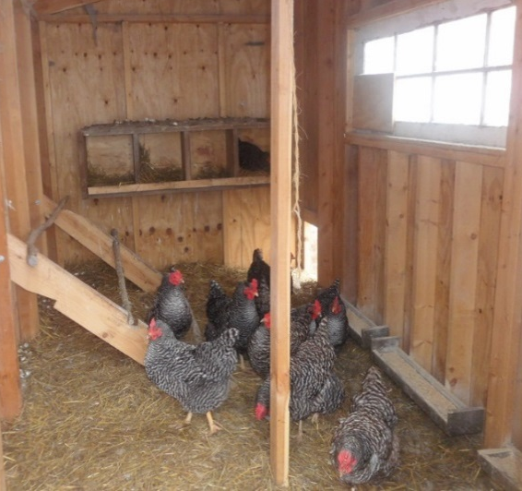
- The owner must feed and water the chickens on a daily basis.

- Outdoor usable space (a run) of at least two (2) square feet per animal shall be provided and be attached to the coop.^{ii} Outdoor usable space must be in the rear yard or side yard and enclosed to prevent chickens from leaving the lot.

- Enclosed housing for chickens shall be set back at least twenty (20) feet from any neighboring residence or the respective setback required in the zoning district for accessory structures, whichever is greater. Mobile chicken housing shall meet the required setbacks at all times.

- Limited Residential Keeping of Rabbits: Required Conditions

- A maximum of [NUMBER] adult rabbits per single- or two-family dwelling unit may be kept.

- Rabbits shall be confined to the lot.
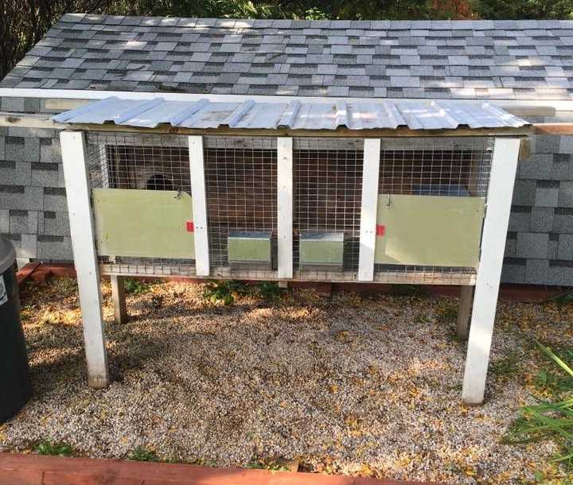
- Enclosed housing for rabbits (cage or hutch) shall be located in the rear yard or side yard, be fully enclosed, roofed, and provide at least five (5) square feet of indoor usable floor space per animal.^{iii} Enclosed housing shall be designed to discourage rodents, dogs, cats, and wildlife from gaining entry.

- The owner must feed and water the rabbits on a daily basis.

- Rabbits shall only be kept within enclosed housing except for monitored exercise periods. Outdoor usable space must be in the rear yard or side yard and enclosed to prevent rabbits from leaving the lot.

- Enclosed housing of rabbits shall be set back at least twenty (20) feet from any neighboring residence or the respective setback required in the zoning district for accessory structures, whichever is greater. Mobile rabbit housing shall meet the required setbacks at all times.

- Limited Residential Keeping of Honeybees: Required Conditions

- A maximum of two (2) hives may be kept on lots less than 10,890 square feet (1/4 acre). On lots at least 10,890 square feet (1/4 acre) but less than 21,780 square feet (1/2 acre), a maximum of four (4) hives may be kept. On lots 21,780 square feet (1/2 acre) but less than 43,560 square feet (1 acre), a maximum of six (6) hives may be kept. On lots 43,560 square feet (1 acre) or greater, a maximum of eight (8) colonies may be kept.^{iv}

- One additional nucleus colony (a maximum of five frames) is allowed for a maximum of three weeks as a measure to control swarming.^{v}

- Hives must be located on an undeveloped area of the lot.

- Hives shall be set back at least 200 feet from any neighboring residence. The setback for hives may be reduced to the respective setback required in the zoning district for accessory structures if a six (6) foot high flyway barrier surrounds the immediate vicinity of the hive(s) consisting of a solid fence, wall, or dense vegetation that prevents a direct line of flight from the hives into neighboring properties or public use right-of-ways. [See Fig. A: Honeybee Setback Diagram]

- Beekeepers shall make every effort to perform hive manipulations as quickly as possible, with minimum disturbance to the bees and at times of the day when outdoor activity of neighbors is minimized.

- Beekeepers shall use best management practices to prevent or minimize swarming. Beekeepers shall take reasonable measures to retrieve swarms.

- The owner must supply water for all hives throughout the active flight season.^{vi}

ADDITIONAL RESOURCES
The Upper Peninsula Food Policy Committee is a subcommittee of the U.P. Food Exchange. The committee works with communities to provide education, draft and recommend regulations, and advocate for public policy that supports the growth of community food systems.

If your community needs assistance revising local plans and ordinances to better accommodate and support the local food system, feel free to reach out to the UPFE Policy Committee at info@upfoodexchange.com or 906-225-0671, ext. 723.

Find this and other resources at www.upfoodexchange.com

i MSU Extension Bulletin E-3136 “Suggestions for Ordinances Allowing Backyard Poultry.” October 2010. http://msue.anr.msu.edu/uploads/resources/pdfs/Suggestions_for_Ordinances_(E3136).pdf
ii Urban Livestock Workgroup Recommendations Report, March 15, 2015. State of Michigan. https://www.michigan.gov/documents/mdard/Urban_Livestock_Workgroup_Report_w_Technical_Workgroup_Guidelines_031315____484099_7.pdf
iii Ibid.
iv Care of Farm Animals GAAMPs - http://www.michigan.gov/documents/mdard/CARE_OF_FARM_ANIMALS_GAAMPs_550744_7.pdf
v Personal communication with Dr. M. Milbrath, MSU Department of Entomology Academic Specialist, 5/21/18
vi Also see Louisiana State University Publication 2524 “Model Beekeeping Ordinance: For Louisiana Local and Municipal Governments.” September 2009. https://www.lsuagcenter.com/NR/rdonlyres/CB2656D7-A2EA-4E6D-8DC3-A88E889E763E/61883/pub2524modelbeekeepingAug09HIGHRES.pdf

